**P.1 LUGANDA LESSON NOTES FOR TERM II 2020**

|  |  |  |  |  |
| --- | --- | --- | --- | --- |
| **Essomo** | **Ennaku** | **Obudde** | **Ekibiina** | **Abayizi** |
| **Luganda** | **P.1** |  |  |  |

**Omutwe : Embeera y’obudde**

**: *Nta nte nti nto ntu***

**Ekiwayi : Ebintu ebikola embeera y’obudde**

**Ebigendererwa : Okusoma nokukuba ebintu ebikola embeera**

**y’obudde.**

**Ekinyusi : Ebintu ebikola embeera y’obudde.**

Omusana Ebire



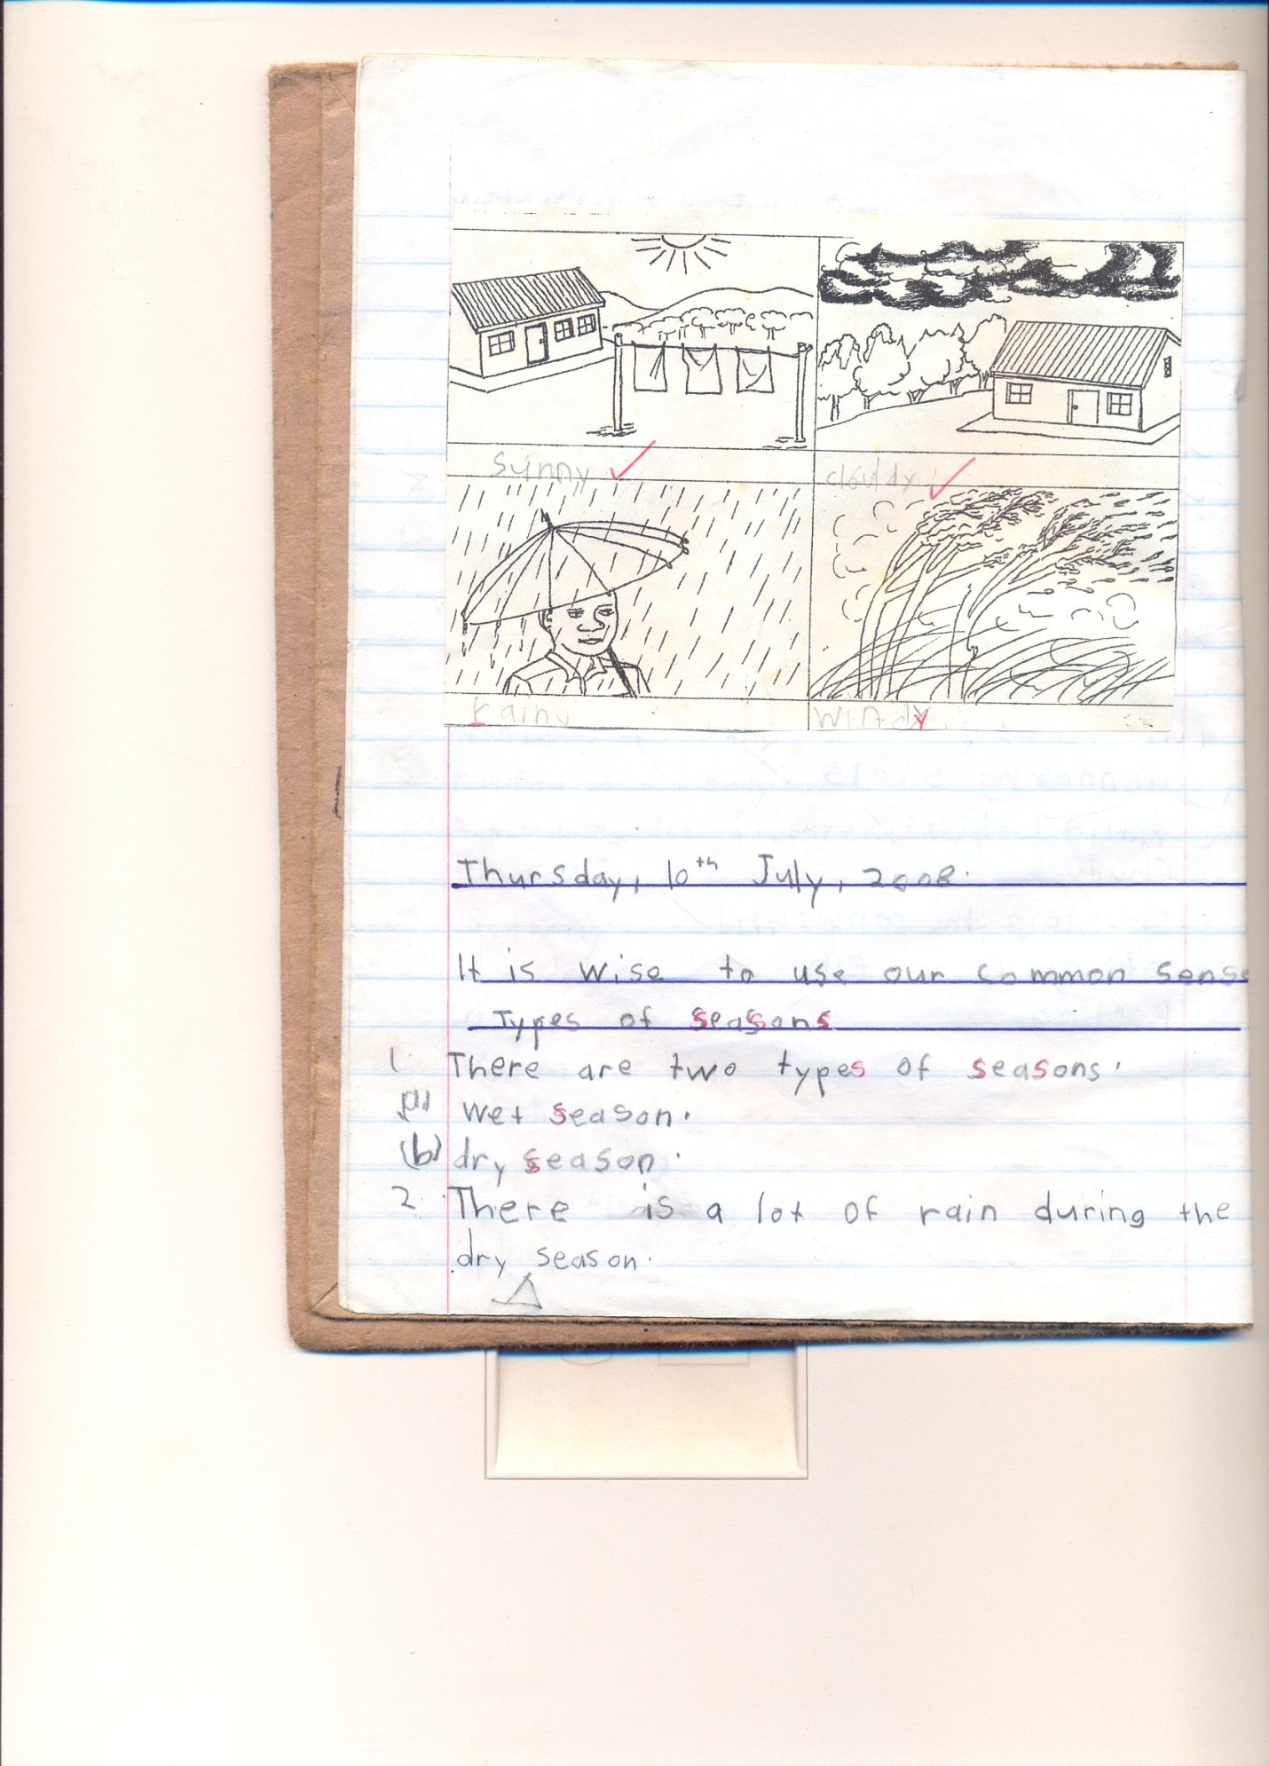Enkuba Kibuyaga



*Omugaso gw’ebire*

**Omulimu**

1. Wandiika ebintu bina ebikola embeera y’obudde.
2. Jjuzaamu ennyingo ezibulamu

om__san__ enk__b__ kib__y__ga eb__re

1. Kuba ebintu ebikola embeera y’obudde.

Omusana kibuyaga ebire enkuba

1. *Kutula ebigambo okole ennyingo*

*omusana, ebire, kibuyaga, ekikome.*

*enkuba obudde*

|  |  |  |  |  |
| --- | --- | --- | --- | --- |
| **Essomo** | **Ennaku** | **Obudde** | **Ekibiina** | **Abayizi** |
| **Luganda** | **P.1** |  |  |  |

**Omutwe : Embeera y’obudde**

**: *Bbugu bbugu - simuliro***

**Ekiwayi : Ennyingo ‘nk’ ne ‘mb’**

**Ebigendererwa : Okuwandiika n’okusoma ebigambo ebyennyingo ‘nk’**

**ne ‘mb’**

**Ekinyusi : Ennyingo ‘nk’**

**Ebigambo**

enkuba enkima enkumbi *enkoko enkasi nkaaba embazzi*

Nankanja embogo embaata  *embagga embuzi embizzi*

**Emboozi**

Nambatya alima emboga

Emboga zimera kunkuba

Omwana akutte embuzi

Nambuya alimisa enkumbi

**Omulimu**

1. Soma okube ebifaananyi

embuzi enkima enkumbi embazzi enkasi.

1. Wandiika ebigambo bibiri ebyennyingo ‘mb’
2. Wandiika ebigambo bisatu ebyennyingo ‘nk’
3. *Kola emboozi okuva mu bigambo bino*

*Enkumbi enkoko*

*mbizzi mbuzi*

|  |  |  |  |  |
| --- | --- | --- | --- | --- |
| **Essomo** | **Ennaku** | **Obudde** | **Ekibiina** | **Abayizi** |
| **Luganda** | **P.1** |  |  |  |

**Omutwe : Embeera y’obudde**

**: *nsa nse nsi nso nsu***

**Ekiwayi : Emirimu egikolebwa**

**Ebigendererwa : Okusoma n’okuwandiika emirimu egikolebwa mu**

**musana.**

**Ekinyusi :**

**Emirimu egikolebwa mu musana**

* Okusaawa - Okukungula
* Okwooza engoye - Okwanika
* Okuwewa - okufukirira
* *Okusambula - okulima*

**Emboozi**

1. *Omulenzi afukirira ennyanya*
2. Maama awewa ebijanjaalo
3. Kasasa asaawa olujja
4. Nakato akungula obulo
5. *Baaba awewa ebijjanjaalo*

**Omulimu**

**Soma emboozi okube ebifaananyi.**

1. Nalule ayoza engoye.
2. Kifufu awewa soya
3. Kafeero afukirira ennyaanya.
4. Magezi asaawa oluggya.
5. *Maama ayanika engoye.*
6. *Omusana gwaaka.*

***Yunga ebigambo bino***

***kusaawa ________________***

*kwooza__________________*

O Kuwewa ________________

Kwanika _________________

Kulima _________________

|  |  |  |  |  |
| --- | --- | --- | --- | --- |
| **Essomo** | **Ennaku** | **Obudde** | **Ekibiina** | **Abayizi** |
| **Luganda** | **P.1** |  |  |  |

**Omutwe : Embeera y’obudde**

**: *kayemba nantabulirirwa – yasaabala bwabumba***

**Ekiwayi : Ennyingo ‘ng’**

**Ebigendererwa : Okusoma n’okuwandiika ebigambo eby’ennyingo ‘ng’**

**Ekinyusi : Ennyingo ‘ng’**

**Ebigambo eby’okuyiga**

engabi enguudo engoye  *wangu engalo*

engulu emmanga wange endongo

**Emboozi**

Nangobi ayambuka engulu

Taata wange asuna endongo

Nangobi ayanula engoye.

**Omulimu**

1. Jjuzaamu ennyingo ezibulamu

Eng__bi __eng__ __do eng__ye eng ____lo endong _____

1. Soma emboozi zino.
2. Ono *bb__goya* wange.
3. Endo__go ekuba nnyo.
4. Engabi erabika bulungi.

|  |  |  |  |  |
| --- | --- | --- | --- | --- |
| **Essomo** | **Ennaku** | **Obudde** | **Ekibiina** | **Abayizi** |
| **Luganda** | **P.1** |  |  |  |

**Omutwe : Embeera y’obudde**

**: *baa bee bii boo buu***

**Ekiwayi : Emirimu egikolebwa**

**Ebigendererwa : Okusoma n’okuwandiika emirimu egikolebwa ku**

**nkuba.**

**Ekinyusi :**

**Emirimu egikolebwa *mu biseera by’enkuba***

* Okusimba / okusiga
* Okulembeka *amazzi*
* Okulima
* Okukoola *ebirime*

**Emboozi**

1. Maama alembeka amazzi
2. Taata asimba ebijanjaalo
3. Senga alima munnimiro
4. Abawala bakoola lumonde

**Omulimu**

**Maliriza emboozi zino**

1. Taata asimba………………….
2. Senga alima ………………..
3. Abawala bakoola…………………..
4. Maama alembeka …………………

(munimiro, ebijanjaalo, amazai, lumonde)

***Ebiseera***

* *Eky’enkuba n’ekyomusana*

***Ebikozesebwa munnimiro***

*Enkumbi oluso embazzi ejjambiya*

*Akaso ekibbo akambe ekisero*

***Emboozi***

***Ebiseera***

*Mwami Mukasa musajja mulimi era mulunzi*

*Ebiseera bwebikyuka, bitataganya byakola.*

*Naddala ekiseera eky’omusana ebintu bye byononeka.Ebsoro bifa, emmere ekala.*

*Enkuba ya migaso mingi. Ebisolo biba biramu.*

*Ebibuuzo*

1. *Mwami Mukasa akola mulumu ki?*
2. *________ bifa mu kiseera ky’omusana.*
3. *Wandiika ebika by’embeera y’obudde bibiri*
4. *Kuba mwami Mukasa ng’alima.*

|  |  |  |  |  |
| --- | --- | --- | --- | --- |
| **Essomo** | **Ennaku** | **Obudde** | **Ekibiina** | **Abayizi** |
| **Luganda** | **P.1** |  |  |  |

**Omutwe : Embeera y’obudde**

**: *ekijja omanyi – kinyaga bitono.***

**Ekiwayi : Enyingo ‘nj’**

**Ebigendererwa : Okusoma ebigambo by’ennyingo n’emboozi**

**Ekinyusi :**

**Ennyingo ‘nj’**

**Ebigambo by’okusoma**

njagala njasa enjuba *ebijanjaalo*

enjoka ennyanja enjaaye

**Emboozi**

1. Ennyanja efuukuuse
2. Enjuba evuddeyo
3. Enjaaye etta enjoka
4. Njagala kulya mmere
5. Ennyanja etuwa ebyennyanja.

**Omulimu.**

1. Wandiika ebigambo bisatu ebyennyingo ‘nj’
2. Soma okube

|  |  |  |  |
| --- | --- | --- | --- |
| Enjuba | Ennyanja | Enjuki | Enjiibwa |
|  |  |  |  |

1. Wuliliza owandiike

emmere njuba ennyanja

1. *Soma emboozi zino wamanga okube ebifaananyi*

*Enjuba eyaka kunnyanja*

*Ebijanjaalo bino nga birungi*.

***Ebintu by’etwambala***

*Essaati sikaati empale magetiisi manvuli*

*Enkofira engatto bulawuzi ekiteteeyi omusipi*

***Kabuuti essawa galubindi omusipi***

|  |  |  |  |  |
| --- | --- | --- | --- | --- |
| **Essomo** | **Ennaku** | **Obudde** | **Ekibiina** | **Abayizi** |
| **Luganda** | **P.1** |  |  |  |

**Omutwe : Obubenje nokwerinda**

**: *tta tte tti tto ttu***

**Ekiwayi : Obubenje mu maka**

**Ebigendererwa : Okusoma, okukuba, nokuwandiika ebintu ebireeta**

**obubenje mu maka.**

**Ekinyusi :**

**Ebintu ebireeta obubenje mu maka**

omuliro akaso empiso *amasanyalaze*

ejjambiya omusumaali ejirita *eccupa eyatise*

amazzi emiti *obutwa*

*Okubbira okugwa okubojebwa nebirala*

**Emboozi**

1. Nakato akaso kamusaze
2. Taata atema omuti nejjambiya
3. Omuliro gwabulabe
4. Omusumaali gufumisse omwana

**Omulimu**

1. Jjuzaamu ennyukuta ezibulamu.

om__liro ak__so emp__so

ej__rita am__zzi om__ti

1. Kuba ebintu ebikola obubenje

akaso omuliro ejirita

1. *Soma okube ebifaananyi*
2. *Nakirya akutte akaso.Maama afumba amazzi*.

|  |  |  |  |  |
| --- | --- | --- | --- | --- |
| **Essomo** | **Ennaku** | **Obudde** | **Ekibiina** | **Abayizi** |
| **Luganda** | **P.1** |  |  |  |

**Omutwe : Obubenje nokwerinda**

**:**

**Ekiwayi : Ebireeta obubenje ku nguudo**

**Ebigendererwa :**

**Emboozi empanvu**

**Obubenje kuluguudo**

Lwali lumu Nampiima yali agenda kussomero nasanga mikwano gye bazannya akapiira muluguudo naye nabegattako.

Mukwano gwe gew bayita Nalule emmotoka yamutomera na menyeka okulu. Okuva olwo balayiira obutaddamu kuzanyira kuluguudo.

**Ebibuuzo**

1. Wandiika omutwe gwe mboozi
2. Ani yali agenda kussomero?
3. Nampiima ne mikwano gye baali bakoola ki kuluguudo?
4. Ani eya tomerwa jemmotoka?
5. Soma okube Nampiima ne mikwano gye nga bazannya akapiira kuluguudo.

|  |  |  |  |  |
| --- | --- | --- | --- | --- |
| **Essomo** | **Ennaku** | **Obudde** | **Ekibiina** | **Abayizi** |
| **Luganda** | **P.1** |  |  |  |

**Omutwe : Obubenje n’okwerinda**

**: *dda dde ddi ddo ddu***

**Ekiwayi : Ebireeta obubenje ku nguudo**

**Ebigendererwa : Okuwandiika ebigambo ebikola obubenje ku nguudo**

**Ekinyusi :**

**Ebireeta obubenje ku nguudo**

* Okuvuga obubi
* Okuvuga endiima
* Okuzanyira mu kubo
* Okuwalampa emiti

**Omulimu**

**Soma okube ebifaananyi**

1. Nantongo atomedwa emmotoka
2. Dereva avugira mu supiidi nene.
3. Tovuga bwonywa mwenge
4. Okuzanyira mu kubo kibi.

***Ebintu ebyobulabe kunguudo***

*Emisota embwa amayinja amasongonvu*

*obunnyamugundo Emmotoka amagaali ppikippiki.*

***Ebintu ebyobulabe ku ssomero***

*Ebigwo / okugwa okwesala amasanyalaze okweyokya.*

***Ebiva mu bubenje***

*Ambwa obulema obulumi okufa okuggwamu omusaayi okufiirwa ebintu by’omubiri ebimu obwavu*

|  |  |  |  |  |
| --- | --- | --- | --- | --- |
| **Essomo** | **Ennaku** | **Obudde** | **Ekibiina** | **Abayizi** |
| **Luganda** | **P.1** |  |  |  |

**Omutwe :**

***:***

**Ekiwayi :**

**Ebigendererwa :**

**:**

**Ekinyusi : Ennyingo “nf” ne “nd”**

***Ebigambo***

*ndaba ndeka ndasa ndiga*

*nfuna nfuba nfumba*

***Emboozi***

1. *Nteesa enfunda eziwera*
2. *Ndawula andabira mu galubindi*
3. *Ndeka ndase omweso*

***Omulimu***

1. *Wuliriza owandiike*
2. *Yunga okole ebigambo*

*ba*

***nfu*** *ka*

*na*

*mba*

1. *Soma okube ebifaananyi*
2. *Maama afumba emmere*
3. *Abaana babuuka omuguwa*
4. *Kato yeetise ekinywa kyenku*

|  |  |  |  |  |
| --- | --- | --- | --- | --- |
| **Essomo** | **Ennaku** | **Obudde** | **Ekibiina** | **Abayizi** |
| **Luganda** | **P.1** |  |  |  |

**Omutwe :**

***:***

**Ekiwayi :**

**Ebigendererwa :**

**:**

**Ekinyusi : Ebyetago mu maka**

***Ebigambo***

*ennyumba amazzi obujanjabi*

*ebyambalo engoye emmere*

***Ebyetaago ebirala***

* *Ssente obukuumi okusoma*

***Omulimu***

1. *Soma okube ebifaananyi*

*Ennyumba amazzi engoye emmere*

1. *Tuuma bano amannya*

**

**______________**

* ______________*

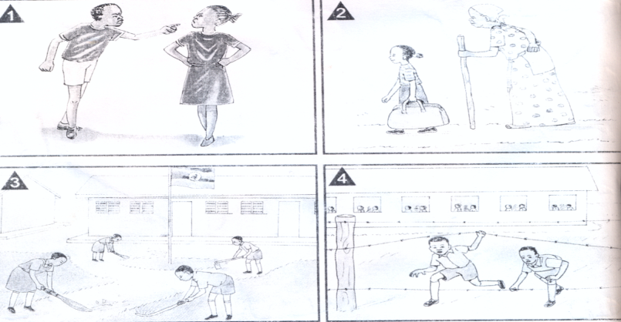

*_____________ _______________*

|  |  |  |  |  |
| --- | --- | --- | --- | --- |
| **Essomo** | **Ennaku** | **Obudde** | **Ekibiina** | **Abayizi** |
| **Luganda** | **P.1** |  |  |  |

**Omutwe : Okubeera awamu**

***: Abayita ababiri –Bejjukanya.***

**Ekiwayi : Obumu mu maka**

**Ebigendererwa : Okutegeera abantu ababeera waka**

**: Okusoma nokuwandiika mannya gabwe**

**Ekinyusi : Abantu ababeera awaka**

Taata Maama Abaana *Senga Kojja Jjajja*

1. Taata yakulira amaka
2. Maama afumba emmere nayoza n’engoye
3. Abaana nabo bayambako emirimu emira;a nga okutyaba enku, okukima amazzi, okwoza ebintu, okulunda ebisolo.

**Omulimu**

1. Wandiika emirimu ebiri abaana gyebkola awaka.
2. Ani akulembera amaka?
3. Maama akola milimu ki awaka?
4. Wandiika*era okube* abantu basatu betusanga awaka.

|  |  |  |  |  |
| --- | --- | --- | --- | --- |
| **Essomo** | **Ennaku** | **Obudde** | **Ekibiina** | **Abayizi** |
| **Luganda** | **P.1** |  |  |  |

**Omutwe : Emmere nemigaso gyayo.**

**: gaa gee gii goo guu**

**Ekiwayi : Amanya g’emmere**

**Ebigendererwa : Okumenya amanya g’emmere**

**: Okusoma nokuwandiika amanya g’emmere.**

**Ekinyusi : Amanya g’emmere**

lumonde amatooke endaggu

muwogo amayuuni embogo

obumonde akalo omuceere

akawunga ensujju

**Emboozi**

Lumonde awomerera

Muwogo akaluba

Amatooke gagonda nnyo

Lumonde mmere nungi

Maama yasimba lumonde

Omusana gukazizza amayuuni

Taata, nsaba kundaggu.

Maama afumba ensujju

Nsasula sente zakawunga.

**Omulimu**

1. Menya amanya g’emmere ataano g’omanyi.
2. Kuba emmere eno gyetulya

|  |  |  |
| --- | --- | --- |
| Lumonde | Amayuuni | Amatooke |
|  |  |  |

1. *Soma okube*

*Maama afumba emmere*

|  |  |  |  |  |
| --- | --- | --- | --- | --- |
| **Essomo** | **Ennaku** | **Obudde** | **Ekibiina** | **Abayizi** |
| **Luganda** | **P.1** |  |  |  |

**Omutwe : Emmere nemigaso gyayo**

**: *Atalukutambulire – Akusibira y’amenvu***

**Ekiwayi : Emigaso gyemmere**

**Ebigendererwa : Okumanya emmere eyenjawulo n’emigaso gyayo**

**Ekinyusi : Emigaso gy’emmere**

**Emmere etuwa amanyi nga**

muwogo kasooli

akawunga amayuuni

lumonde obumonde

omuceere

**Omulimu**

**Soma okube *ebika by’emmere***

|  |  |
| --- | --- |
| Lumonde | Muwogo |
|  |  |
| Amatooke | Kasooli |
|  |  |

***Emiwendo***

***1 – emu***

***2 – bbiri***

***4- nnya***

***8 – munaana***

3- ***ssatu***

***6 – Mukaaga***

***10 – kkumi***

***7 – musanvu***

***5 – ttaano***

***9 – mwenda***

***20 - abiri***

***30 – asatu***

***40 – ana***

***50 – attano***

***60 – nkaaga***

***Omulimu***

1. ***Tambuza akaguudo ku miwendo***

***8 mwenda***

***10 mukaaga***

***7 munaana***

***6 kkumi***

***9 musanvu***

1. ***Wandiika emiwendo gino mubigambo   
    1= ___________________ 4= ____________________***

***2= ___________________ 5= ____________________***

***3= __________________***

|  |  |  |  |  |
| --- | --- | --- | --- | --- |
| **Essomo** | **Ennaku** | **Obudde** | **Ekibiina** | **Abayizi** |
| **Luganda** | **P.1** |  |  |  |

**Omutwe : Emmere nemigaso gyaayo**

**: *nja nje nji njo nju***

**Ekiwayi : Emigaso gyemmere**

**Ebigendererwa : Okusoma nokuwandiika emigaso gyemmere**

**Ekinyusi : Emigaso gyemmere**

**Emmere ezimba omubiri okugeza nga**

amagi ennyama amata

ebijanjalo ebyennyanja

soya ebinyebwa

**Omulimu**

1. Soma *era owandiike*

* Amagi gawooma nnyo.
* Tasata aleese ebinyebwa
* Maama afumbye ebijanjaalo

1. Jjuzaamu ennyingo ezibulamu

ama__gi enny__ma

eng__ge s__ya

1. *Soma okube ekifaananyi.*

*Ekyennyanja kiri kussigiri*

***Gyetujja emmere***

*Mu nyanja mu nimiro mu katale*

*mu migga ku nsolo ku bimera*

*mu madduuka*

***Emigaso gy’emmere ku mibiri gyaffe***

*Etuyamba okuba abalamu Etuwa amanyi Etuyamba okukula obulungi.*

***Engeri z’okukuuma mu emmere nga nnugi.***

*Okugibikkako okugyoza okugeza lumonde okugikalirira*

*okigifumba okujjanika ku musana Okutereka.*

|  |  |  |  |  |
| --- | --- | --- | --- | --- |
| **Essomo** | **Ennaku** | **Obudde** | **Ekibiina** | **Abayizi** |
| **Luganda** | **P.1** |  |  |  |

**Omutwe : *langi***

**:**

**Ekiwayi :**

**Ebigendererwa :**

**Ekinyusi :*Ebika byalangi***

***Ezirugavu***

***Kyenvu***

***Enjeru***

***Emyufu/ kasaayi***

***Kitaka***

***Kiragala***

***Omulimu***

1. ***Sainga langi ezikuwereddwa***